Guide to prestudying correctly
What is the purpose of prestudy?
Prestudy is an important part of a studying system because it primes the brain for deeper learning. Much of the difficulty with processing information is that the rate and density of information we need to process during lectures, classes or even meetings can be "too much, too fast", and sometimes "too much, too fast and too complicated".
Prestudying can reduce this load when done correctly.
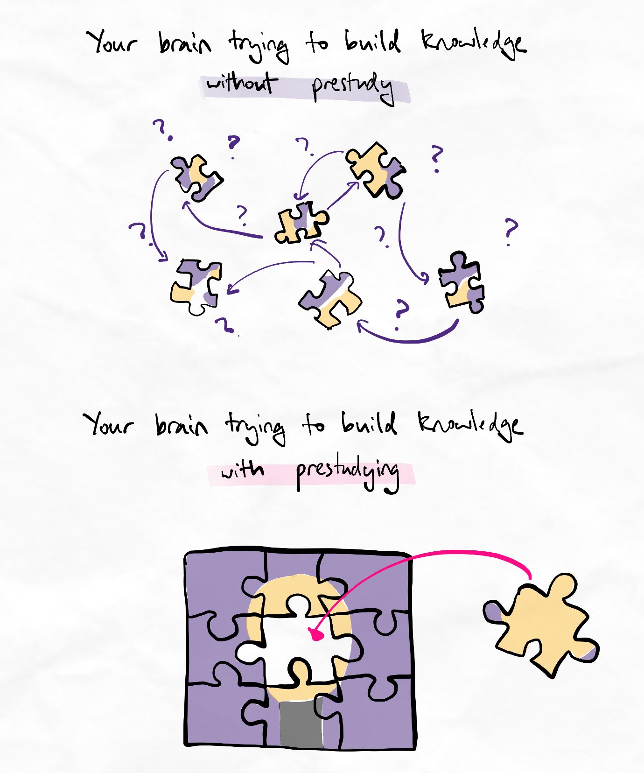
Effective prestudying helps give new information a place to fit.
Prestudying spreads the load
Instead of trying to figure out everything for the first time during an intensive main learning event such as a class, lecture, workshop, or long study session, prestudying addresses the big-picture questions in advance.
This frees up cognitive resources so that your brain can focus on making sense of the more detailed information later.
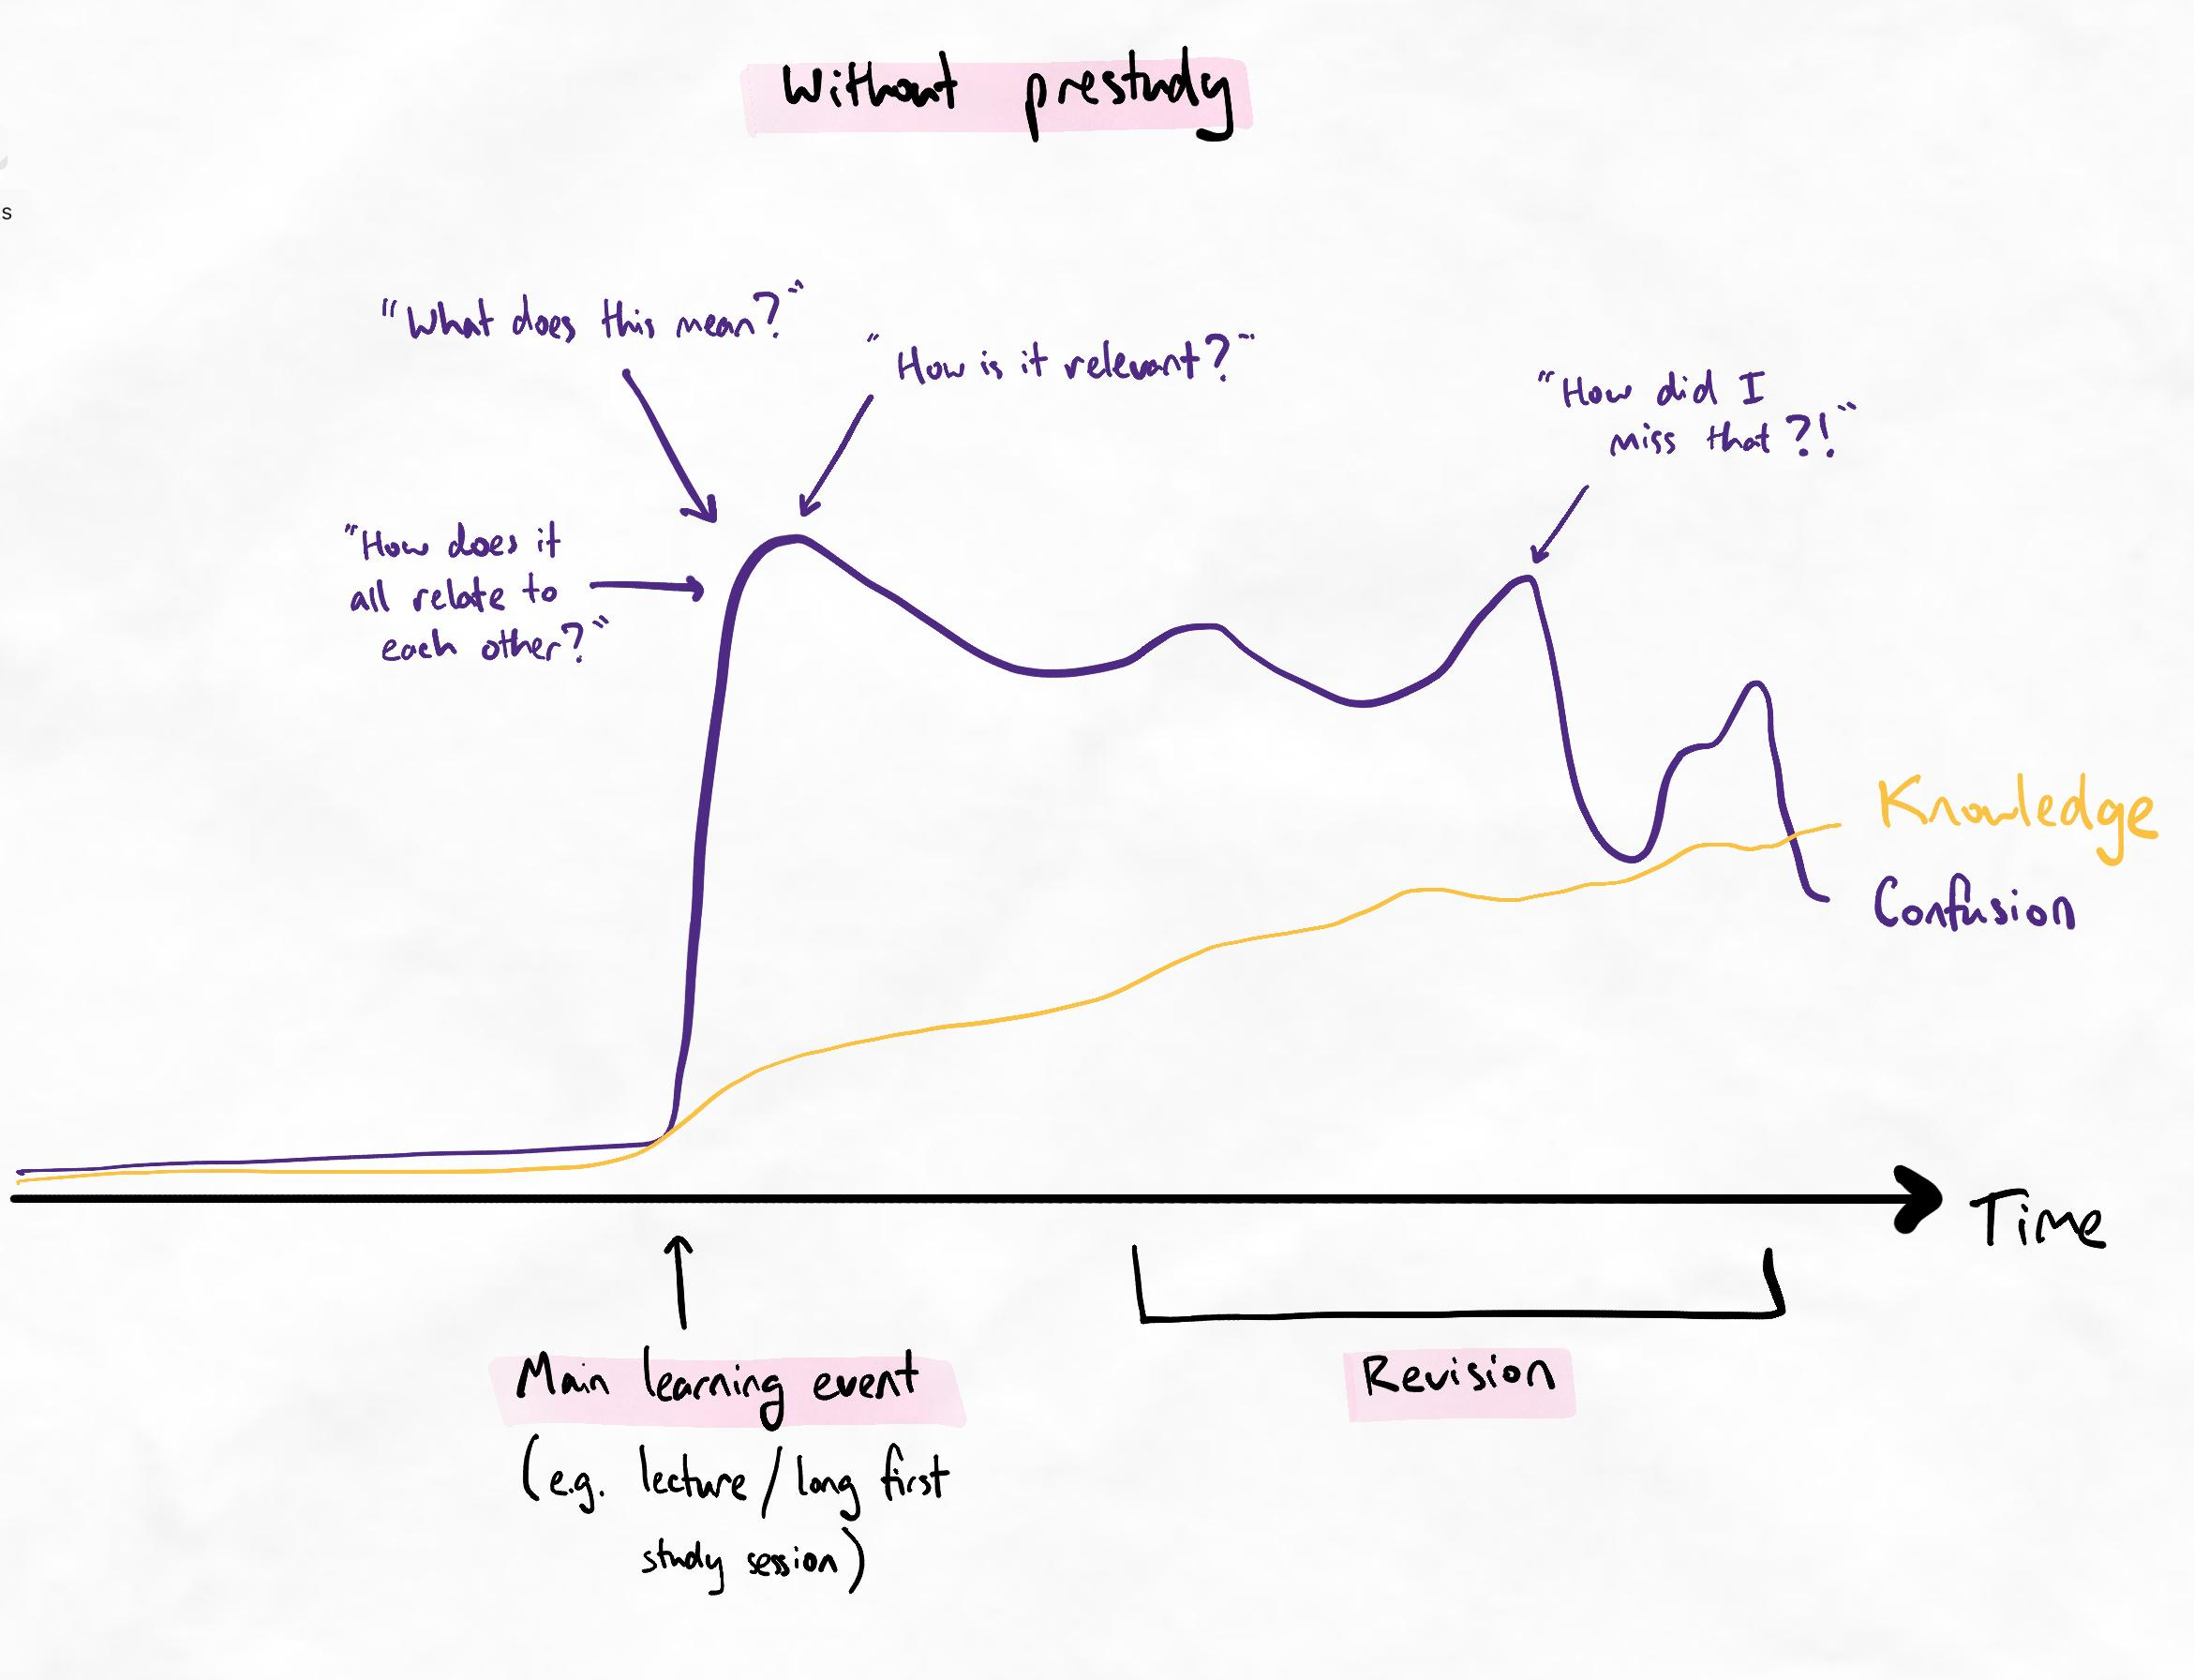
The overload during the initial learning event is difficult to recover from.
When we enter an intensive learning event without priming our brain, it easily enters cognitive overload. This makes information easier to forget, and knowledge is slower to build. In effect, we are fighting an uphill battle.
When these events occur on a daily or weekly basis, it is challenging to recover from this consequence. In many cases, it is so challenging that we compromise on the knowledge that we can build by taking shortcuts or sacrificing our performance.
For the learner, it feels more overwhelming with every class or lecture.
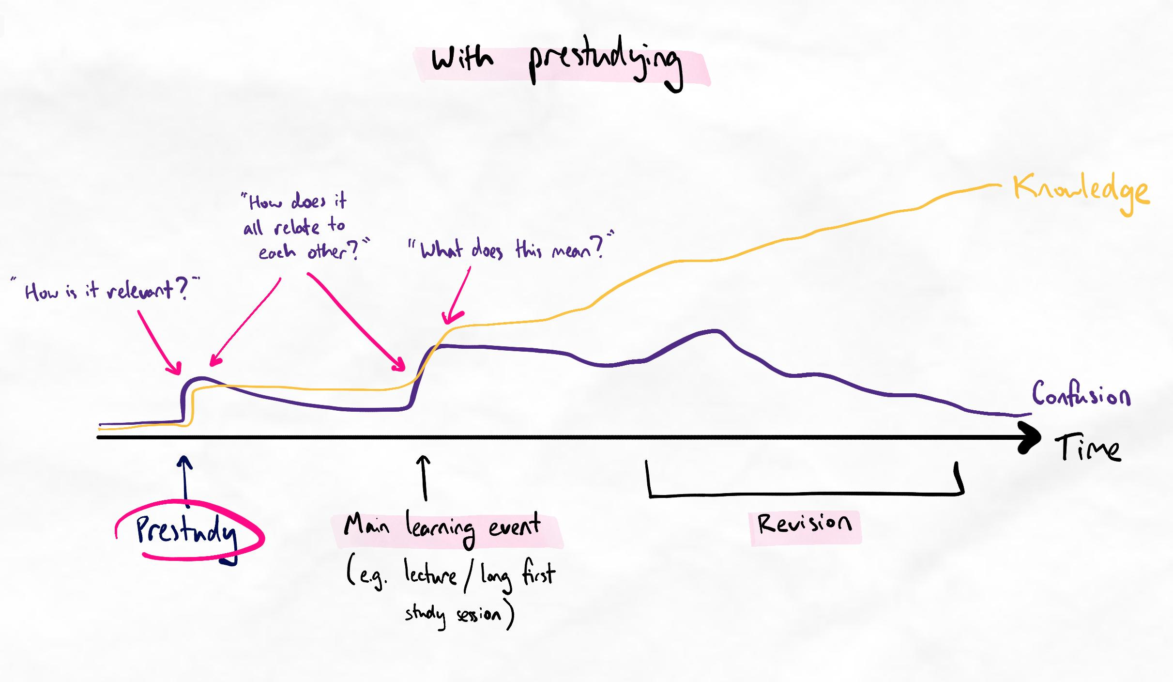
Our brain can focus on fewer things per session with good prestudying.
On the other hand, with effective prestudying, we spread the confusion and cognitive load across multiple sessions.
We focus on building a big-picture understanding of the relevance first, then learning about greater details. Over time, we become less confused and it is easier to understand new information as our foundation is stronger. Knowledge is faster and easier to build.
You've prestudied correctly if...
- You have a clear big-picture understanding of the topic
- You have covered the entire topic or sub-topic, not just one class or lecture
- You do not have any details or facts memorised yet (i.e. you were exclusively focused on the big picture)
- You see how the major ideas of the topic relate to each other and could be grouped together
- You have some hypotheses around how the concepts might relate to each other
- You feel ready to learn more detail
How much should you prestudy?
It's best to prestudy as much as you can before classes or lectures if you're in a formal curriculum. This is because assessments are timed to the end of these classes, so studying ahead gives you more time for revision.
High quality and comprehensive prestudy is one of the first steps that is necessary to truly break away from the study grind.
However, simply covering content is not sufficient because you are unlikely to have the retention, nuance and level of mastery required. Furthermore, most learners lack the efficiency of study skills to actually study comprehensively at a pace faster than lectures and classes. In fact, it's usually the opposite in that class or lecture pace is too fast and they gradually fall behind!
Correct prestudying
Correct prestudying technique involves framing the learning and creating organisational structure. This should always be one of the first steps involved in learning.
Even if prestudy is done so comprehensively that lectures or classes become unnecessary, the first stage of the study session should still be a framing and organising step.
If there isn't enough time to prestudy comprehensively, then doing only this step is still incredibly beneficial for overall efficiency.
Correct framing involves...
- Avoiding smaller details
- Identifying the main ideas or groups of ideas
- Identifying the key relationships between these ideas and groups of ideas
- Gaining a big-picture understanding of the topic
Most learners do not realise what the intention of prestudy is and have insecurity about not learning smaller details during prestudy. However, committing to details in the early stages of studying activates isolated, lower-order learning processes that waste time and make content much more difficult to understand.
Tip
The main ideas and relationships identified in this step should be represented in some form of notetaking if viable. If this is not possible, the mental exercise of correct priming and framing during prestudy is still beneficial.
If writing notes, relational and non-linear notetaking is best, such as mindmaps, because it allows the expression of complex relationships very easily to a level of accuracy that is almost impossible with linear notetaking.
When to prestudy
This is the easiest to answer.
You can prestudy at any time before the main learning event. This entirely depends on your time availability. A common strategy is to prestudy for the upcoming week in the prior weekend, but many students will also prestudy for the day in the morning of.
For high school students with moderately efficient techniques, you should be able to prestudy at least 4 to 6 weeks of content in a single weekend, allowing you to completely move beyond the class pace and completely escape the exam study grind.
If you don't have any time, even a 10-minute skim before the class is beneficial, as long as the above principles are still followed.

